**DATABASE:**

Database is a collection of inter-related data which helps in efficient retrieval, insertion and deletion of data from database and organizes the data in the form of tables, views, schemas, reports etc. Database is a collection of data stored in a format that can easily be accessed.

A database is an application that stores the organized collection of records. It can be accessed and manage by the user very easily. It allows us to organize data into tables, rows, columns, and indexes to find the relevant information very quickly. Each database contains distinct API for performing database operations such as creating, managing, accessing, and searching the data it stores. Today, many databases available like MySQL, Sybase, Oracle, MongoDB, PostgreSQL, SQL Server, etc. In this section, we are going to focus on MySQL mainly.

**DDL [DATA DEFINITION LANGUAGE]:**

DDL is short name of Data Definition Language, which deals with database schemas and descriptions, of how the data should reside in the database.

# CREATE: to create a database and its objects like (table, index, views, store procedure, function, and triggers).

# ALTER: alters the structure of the existing database.

# DROP: delete objects from the database.

# TRUNCATE: remove all records from a table, including all spaces allocated for the records are removed.

# COMMENT: add comments to the data dictionary.

# RENAME: rename an object.

**DML [DATA MANIPULATION LANGUAGE]:**

DML is short name of Data Manipulation Language which deals with data manipulation and includes most common SQL statements such SELECT, INSERT, UPDATE, DELETE, etc., and it is used to store, modify, retrieve, delete and update data in a database.

# SELECT: retrieve data from a database

# INSERT: insert data into a table

# UPDATE: updates existing data within a table

# DELETE: Delete all records from a database table

# MERGE: UPSERT operation (insert or update)

# CALL: call a PL/SQL or Java subprogram

# EXPLAIN PLAN: interpretation of the data access path

# LOCK TABLE: concurrency Control

**Database Management System [DBMS]:**

The software which is used to manage database is called Database Management System (DBMS). For Example, MySQL, Oracle etc. are popular commercial DBMS used in different applications.

DBMS allows users the following tasks:

**DATA DEFINITION:**

It helps in creation, modification and removal of definitions that define the organization of data in database.

**DATA UPDATING:**

It helps in insertion, modification and deletion of the actual data in the database.

**DATA RETRIEVAL:**

It helps in retrieval of data from the database which can be used by applications for various purposes.

**USER ADMINISTRATION:**

It helps in registering and monitoring users, enforcing data security, monitoring performance, maintaining data integrity, dealing with concurrency control and recovering information corrupted by unexpected failure.

**MYSQL: MY STRUCTURE QUERY LANGUAGE**

MySQL is currently the most popular database management system software used for managing the relational database. It is open-source database software, which is supported by Oracle Company. It is fast, scalable, and easy to use database management system in comparison with Microsoft SQL Server and Oracle Database. It is commonly used in conjunction with PHP scripts for creating powerful and dynamic server-side or web-based enterprise applications.

It is developed, marketed, and supported by MySQL AB, a Swedish company, and written in C programming language and C++ programming language. Many small and big companies use MySQL. MySQL supports many Operating Systems like Windows, Linux, MacOS, etc. with C, C++, and Java languages.

MySQL was created by a Swedish company, MySQL AB, founded by David Ax mark, Allan Larsson and Michael Monty Widenius. Original development of MySQL by Widenius and Ax mark began in 1994. The first version of MySQL appeared on 23 May 1995.

***MySQL is a Relational Database Management System (RDBMS) software that provides many things, which are as follows:***

# It allows us to implement database operations on tables, rows, columns, and indexes.

# It defines the database relationship in the form of tables (collection of rows and columns), also known as relations.

# It provides the Referential Integrity between rows or columns of various tables.

# It allows us to updates the table indexes automatically.

# It uses many SQL queries and combines useful information from multiple tables for the end-users.

**SOME POPULAR SQL SOFTWARE:**

1. ORACLE 2. MYSQL 3. MS SQL SERVER 4. POSTGRESQL 5. MONGODB

**NOSQL:**

NoSQL is not a table based database. NoSQL databases are document based. MONGODB, REDIS, CASSANDRA are the example of NoSQL.

**MYSQL ADVANTAGES:**

1. cross platform.

2. used with multiple languages like JAVA, PHP, node js, python, C#.

3. MySQL software is open source.

4. MySQL is RDBMS.

5. the MySQL database server is fast, reliable, scalable and easy to use.

6. MySQL server works in client/server or embedded systems.

**MYSQL COMMANDS:**

**CREATE DATABASE & USE DATABASE COMMAND:**

Create command = create database_name ;

Use command = use database_name ;

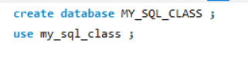

**DATATYPES IN MYSQL:**

**1. STRING:**

char() = 0 to 255

varchar() = 0 to 65,535

binary() = 0 to 255

varbinary() = 0 to 65,535

tinytext() = 255 character

text() = 65,535 bytes

mediumtext() = 16,777,215 character

longtext = 4,294,967,295 character

tinyblob = 255 bytes

blob() = 65,535 bytes

mediumblob() = 16,777,215 bytes

longblob() = 4,294,967,295 bytes

enum(val1, val2, val3,….) = list up to 65,535 values

set(val1, val2, val3,……..) = list up to 64 values

**2. NUMERIC:**

bit()= 1 to 64

tinyint() = -128 to 127

int() = -2,147,483,648 to 2,147,483,647

integer() = 2,147,483,648 to 2,147,483,647

smallint() = -32,768 to 32,767

mediumint() = -83,88,608 to 83,88,607

bigint() = -922,337,203,685,447,758,808 to 922,337,203,685,447,758,807

bool = 0 / 1

boolean = 0 / 1

float(p) = 255.568

double(size, d) = 255.568

decimal(size, d) = size = 60, d = 30

dec(size, d) = size = 60, d = 30

**3. DATE AND TIME:**

date = 1000-01-01 to 9999-12-31 = (year-month-date)

datetime(fsp) = year-month-date hour:minute:second

timestamp(fsp) = year-month-date hour:minute:second

time(fsp) = hour:minute:second

year = four digit format -> 1901

**Create table command:**

create table table_name(column1 datatype, column2 datatype, column3 datatype,………);

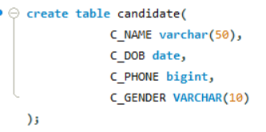

**Insert data command:**

Insert into table_name (column1, column2,……)

Values

(value1, value2,…….), (value1, value2,…..), (value1, value2,……),…………..;

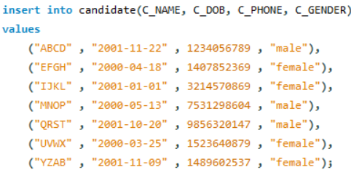

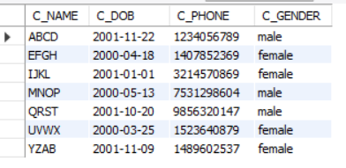

**MYSQL CONSTRAINTS:**

1. not null 2. unique 3. default 4. Check

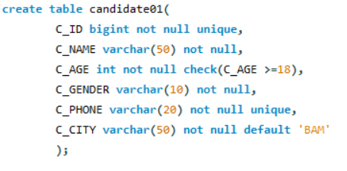

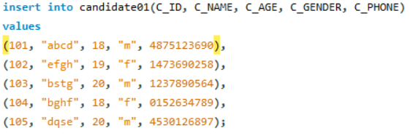

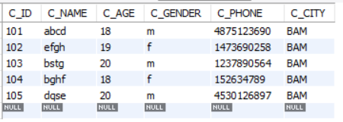

**Select command in mysql:**

**select * from demo;**

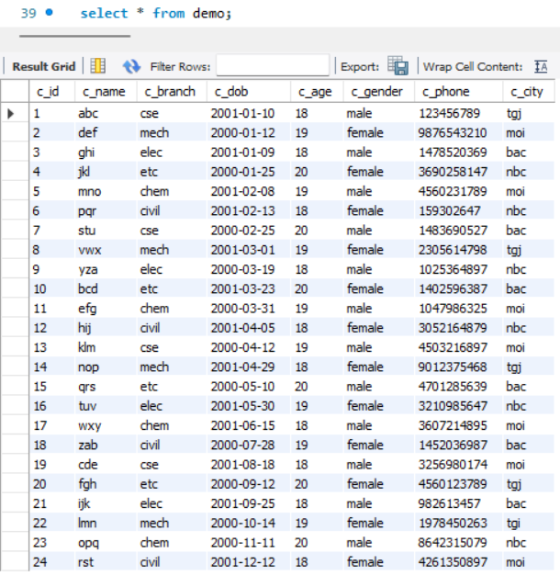

**select c_id, c_name, c_age from demo;**

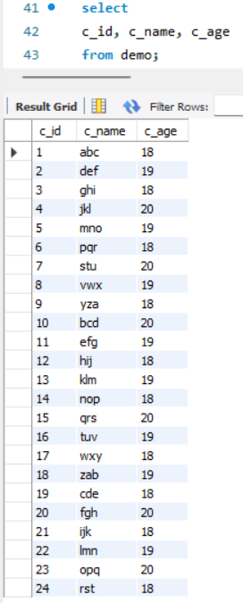

**select c_id as “student id”, c_name as “student name” from demo;**

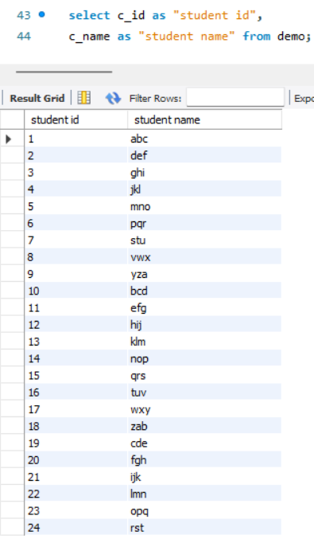

**where clause with select command in mysql:**

you use these comparison operators in where clause ( =, >, <, >=, <=, <>/!=, between, like, in )

**Select * from demo where c_gender = “male”;**

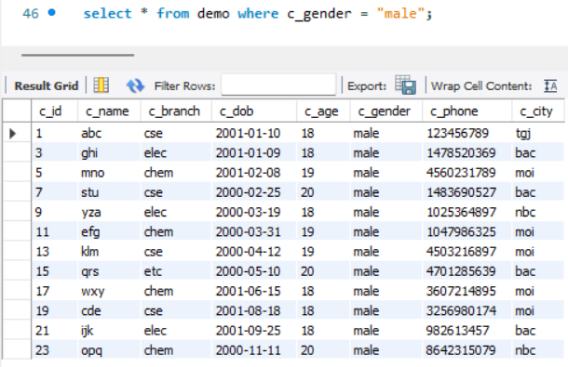

**Select * from demo where c_age = 20 ;**

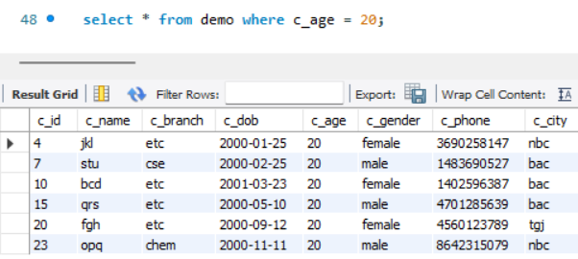

**Select * from demo where c_age < 20;**

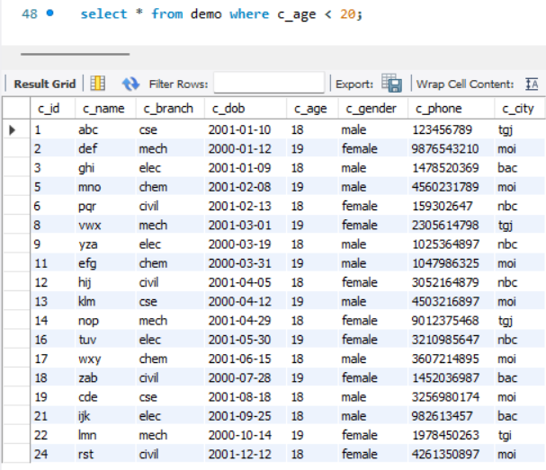

**Select * from demo where c_age > 18;**

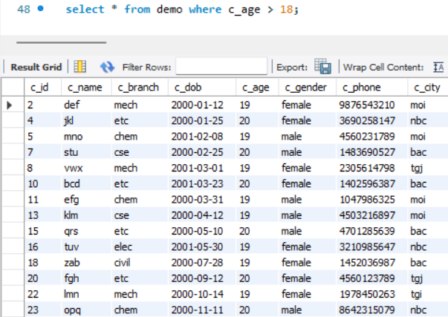

**Select * from demo where c_age >= 19;**

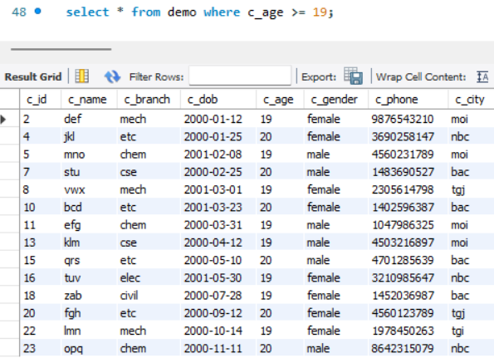

**Select * from demo where c_age <= 19;**

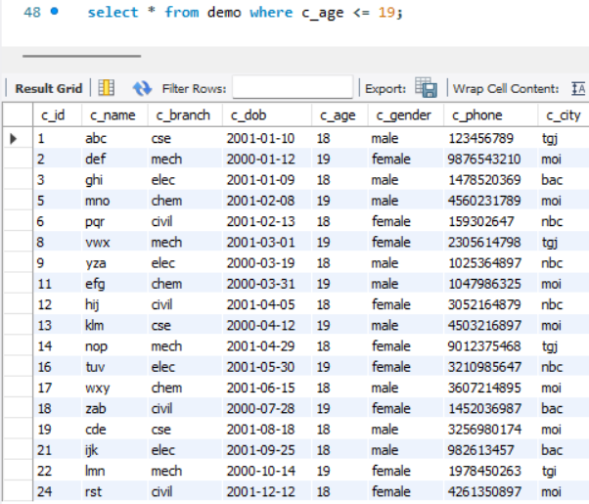

**Select * from demo where c_branch != “civil”;**

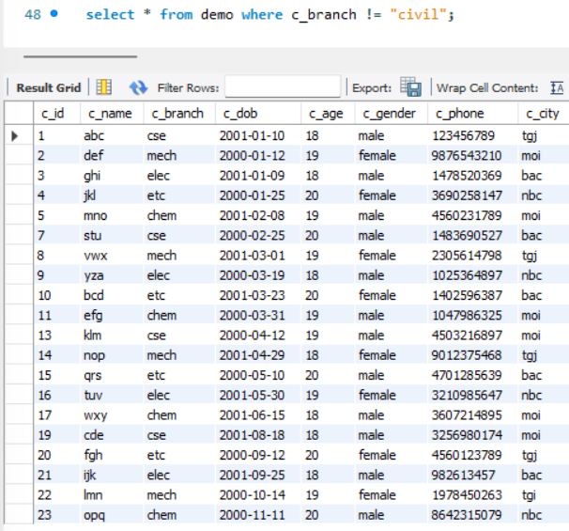

**AND, OR, NOT OPERATOR IN MYSQL:**

AND = WHEN BOTH CONDITIONS ARE CORRECT

OR = ONE CONDITION IS CORRECT

**select * from demo where c_age > 18 and c_age < 20 ;**

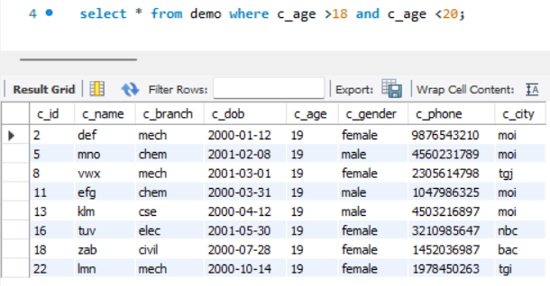

**Select * from demo where c_age = 18 and c_branch = “civil” and c_gender = “female” ;**

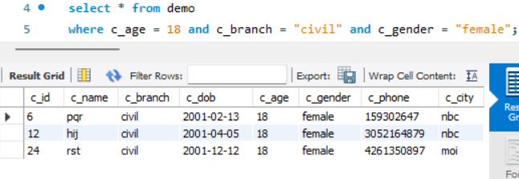

**select * from demo where c_age > 18 or c_branch = "mech";**

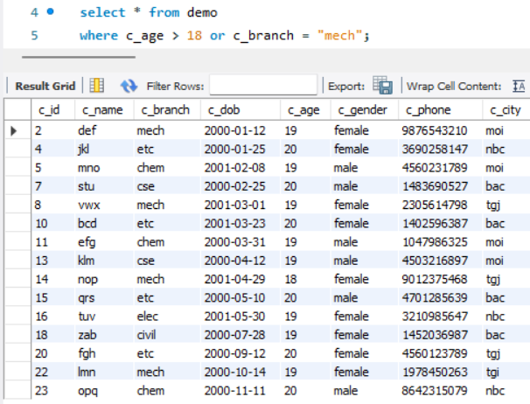

**select * from demo where c_branch = "etc" or c_city = "nbc";**

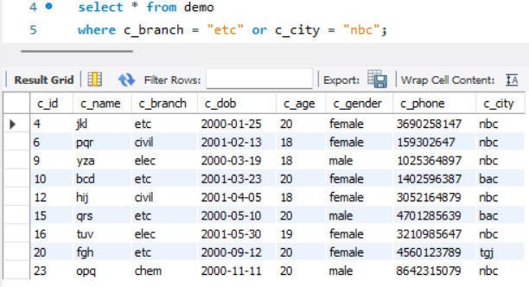

**select * from demo where not c_branch = "etc" and c_city = "tgj";**

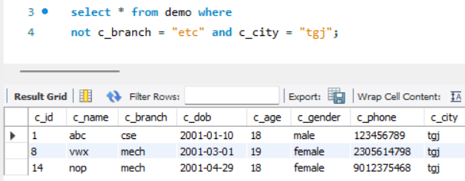

**select * from demo where not c_gender = "male" or c_age = 20;**

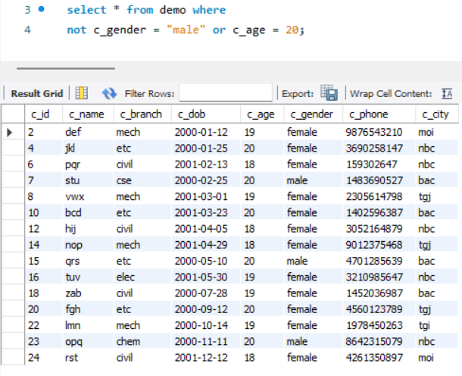

**select * from demo where not c_gender = "male" or (c_age < 19 and c_branch = "etc");**

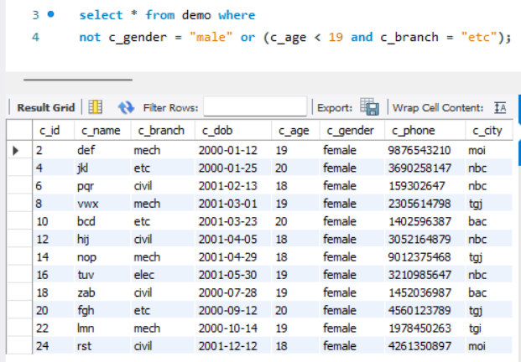

**MY SQL IN OPERATOR:**

**select * from demo where c_branch in("cse", "chem");**

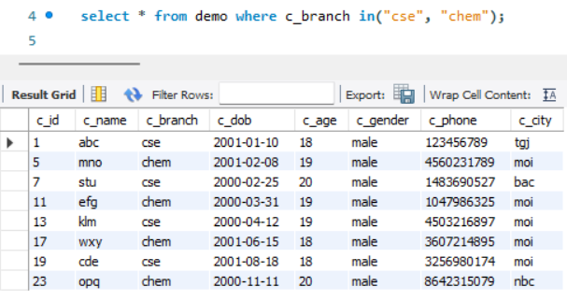

**select * from demo where c_branch not in("cse" , "elec") and c_gender in("male");**

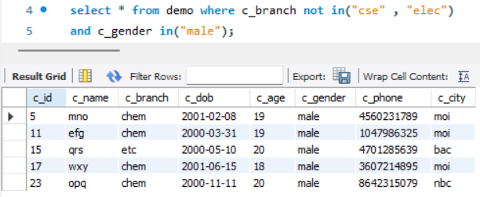

**MY SQL BETWEEN OPERATOR:**

**select * from demo where c_id between 5 and 10 ;**

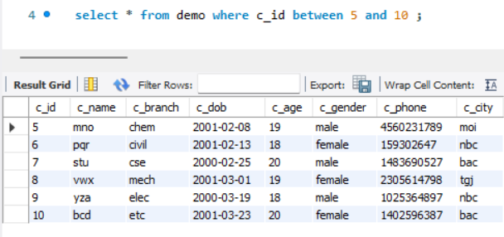

**select * from demo where c_dob between "2000-01-01" and "2000-06-01";**

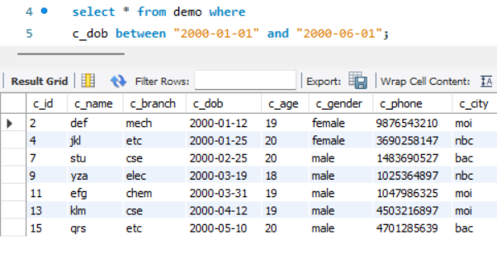

**select * from demo where c_age not between 19 and 20;**

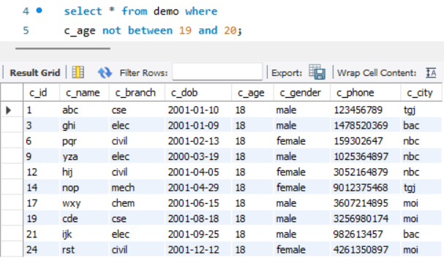

**select * from demo where c_name between "a" and "f";**

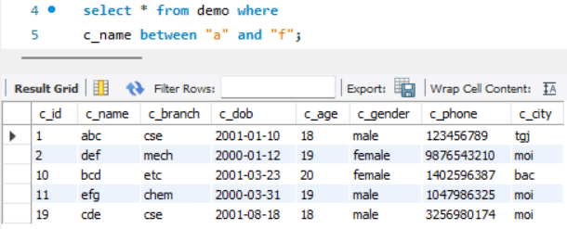

**MYSQL LIKE OPERATOR:**

**PATTERN DESCRIPTION**

like ‘a%’ start with “a”

like ‘%a’ end with “a”

like ‘%am%’ have “am” in any position

like ‘a%m’ start with “a” and end with “m”

like ‘_a%’ “a” in second position

like ‘__a%’ “a” in third position

like ‘_oy’ “o” in second position and “y” in third position

**** use select * from demo where binary c_name like “R%” and “a_m%”; ****

**select * from demo where c_name like 'd%'; = start with “d”**

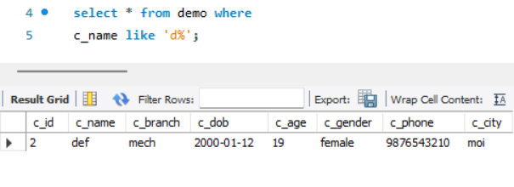

**select * from demo where c_name like '%o'; = end with “o”**

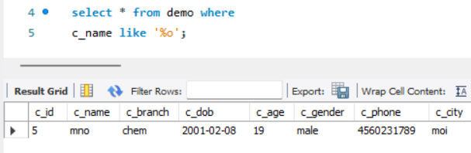

**select * from demo where c_name like '%jk%';**

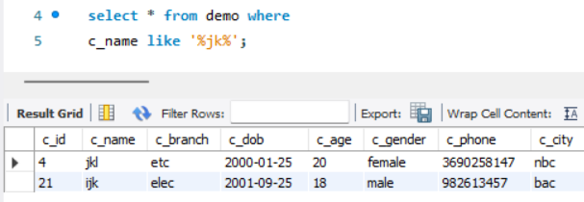

**select * from demo where c_name like 'y%a';**

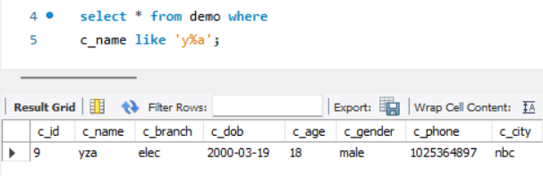

**select * from demo where c_name like '_f%';**

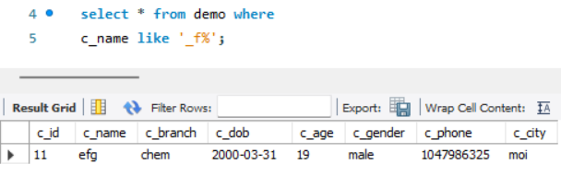

**select * from demo where c_name like '__y%';**

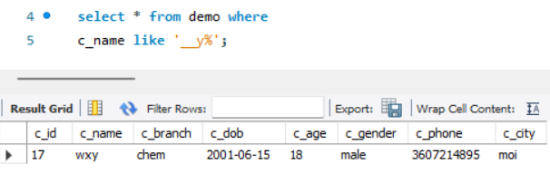

**select * from demo where c_name like '_rs';**

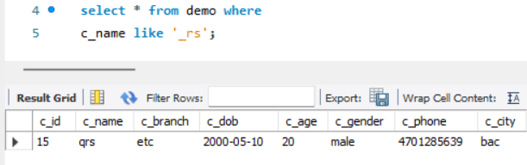

**select * from demo where c_branch not like 'c%';**

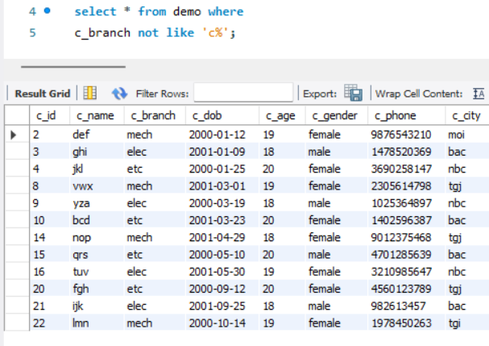

**SELECT WITH REGULAR EXPRESSION:**

**SIGN** **PATTERN** **DESCRIPTION**

^ ‘^ra’ begging of string

$ ‘an$’ end of string

[…] ‘[rms]’ any character listed between the square bracket []

^[…] ‘^[rms]’ begins with any character listed between the square []

[a-z] ‘[a-h]e’ match with in the range

P1|p2|p3 tom|doc|hari matches any of the patterns p1, p2, or p3.

**select * from demo where c_name regexp '^a';**

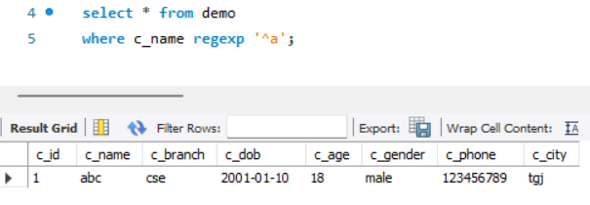

**select * from demo where c_name regexp 'kl$';**

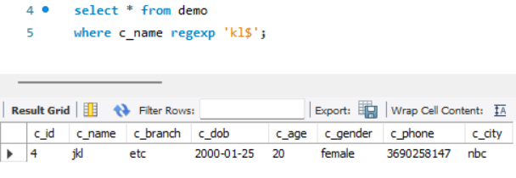

**select * from demo where c_name regexp '[arj]';**

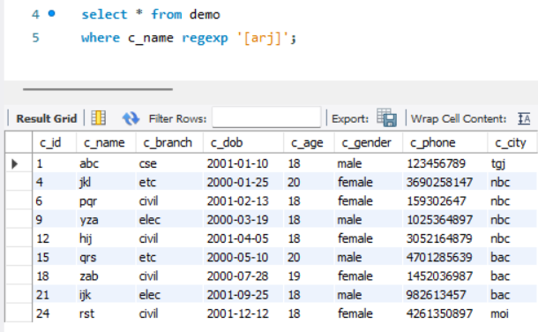

**select * from demo where c_name regexp '^[mdj]';**

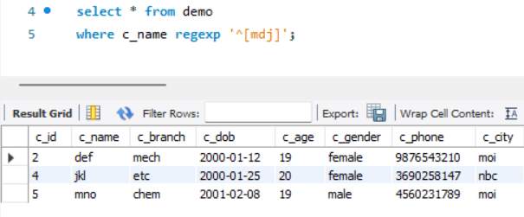

**select * from demo where c_name regexp '^[a-z]r';**

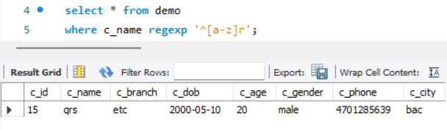

**select * from demo where c_name regexp 'ab';**

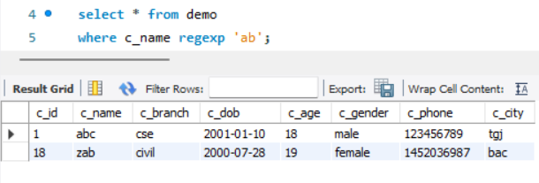

**select * from demo where c_name regexp 'ab|ef|jk';**

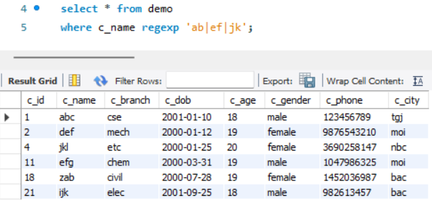

**\*\*\* you can mix all above pattern with each other for efficient data output.\*\*\***

**select * from demo where c_name regexp '[ab]c';**

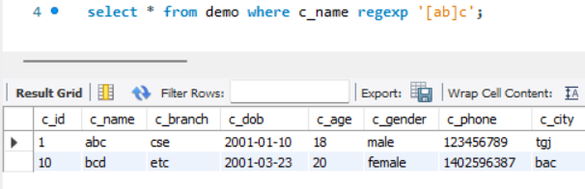

**MYSQL ORDER BY & DISTINCT:**

**ORDER BY:**

**select * from demo order by c_name asc;**

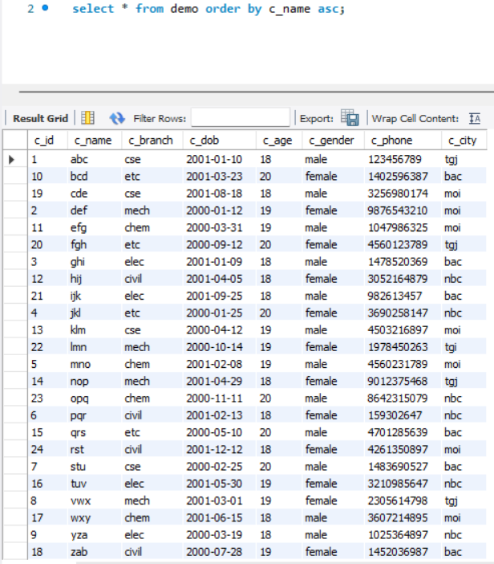

**select * from demo order by c_name desc;**

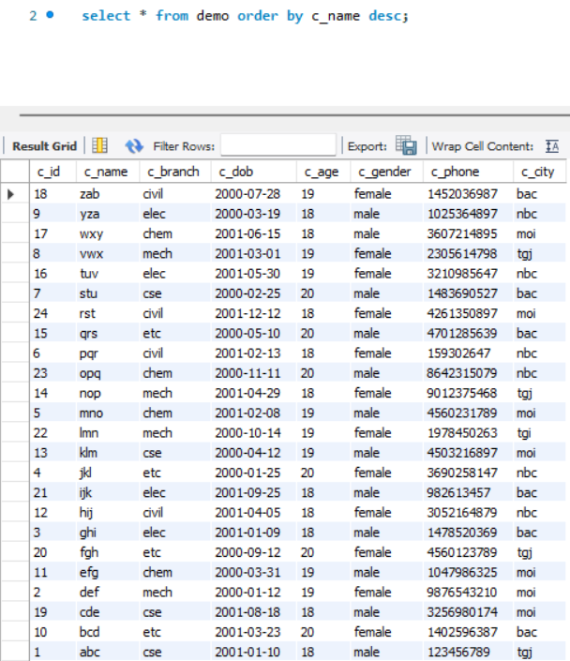

**select * from demo where c_city="moi" order by c_name asc;**

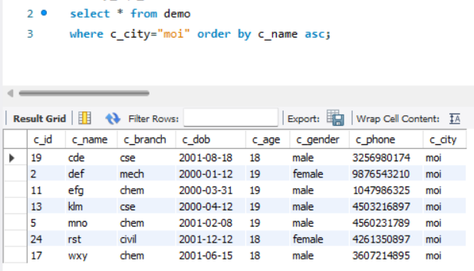

**DISTINCT:**

**select distinct c_city from demo;**

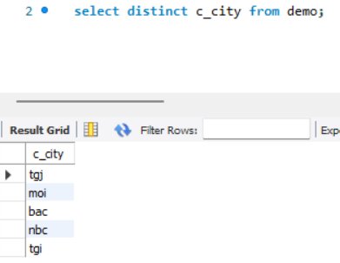

**select distinct c_age from demo;**

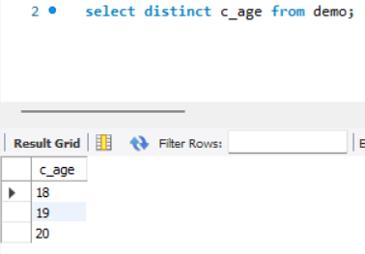

**MYSQL IS NULL & NOT NULL:**

**Is null:**

**select * from demo where c_name is null;**

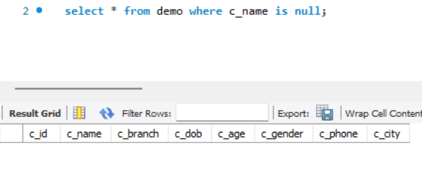

**select * from demo where c_name is not null;**

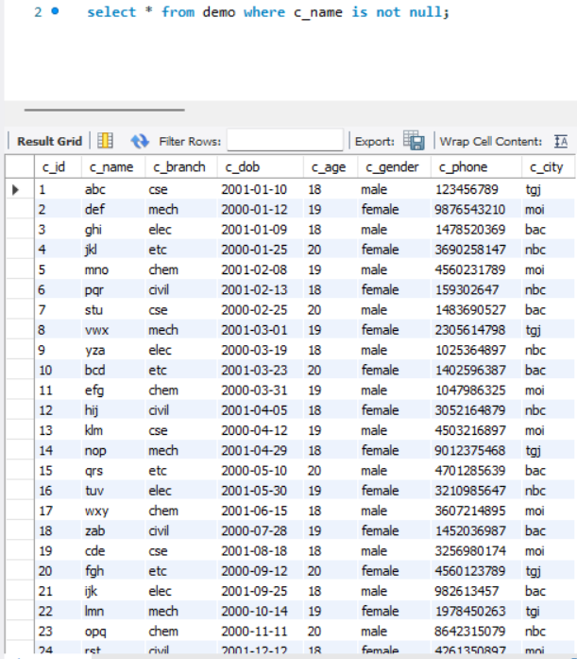

**MYSQL LIMIT & OFFSET:** limit 3, 4 = 3 is offset and 4 is limit

**LIMIT:**

**select * from demo where c_age < 19 limit 5;**

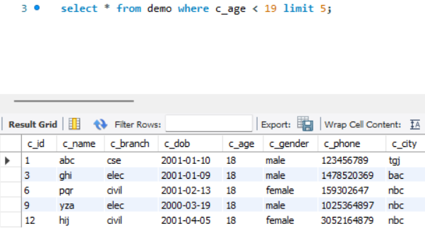

**select * from demo limit 5;**

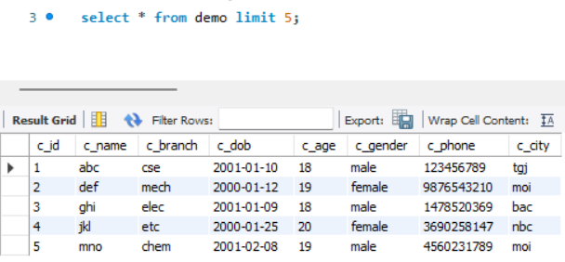

select * from demo limit 3 , 4;

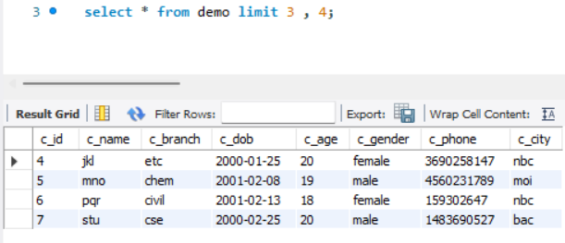

**MYSQL AGGREGATE FUNCTIONS:**

**Count(column_name) Max(column_name) avg(column_name)**

**Min(column_name) Sum(column_name)**

**select count(c_id) from demo ;**

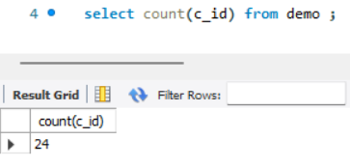

**select max(c_age) from demo ;**

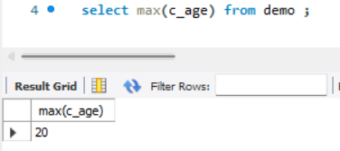

**select min(c_age) from demo ;**

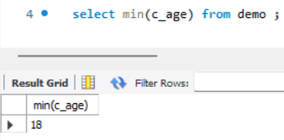

**select avg(c_age) from demo ;**

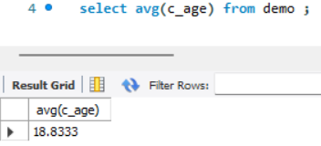

**select sum(c_age) from demo where c_city="bac" ;**

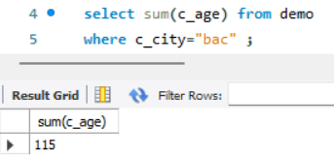

**select count(c_gender = "male") from demo where c_dob between "2000-01-01" and "2000-06-01";**

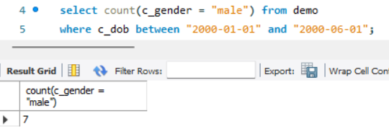

**MYSQL UPDATE COMMAND:**

**Update table_name set column1 = value1, column2 = value2,….. where condition;**

**update demo set c_age = 19, c_branch="mech" where c_id = 10;**

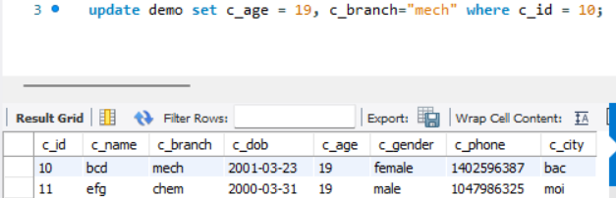

**update demo set c_city = "tgi" where c_id in (23, 13);**







**MYSQL COMMIT AND ROLLBACK:**

Roll back means what we change in our table through code it reverse all the process. Commit means what ever we change in sql to a table it store permanent if we use commit.

Rollback used for only insert, update and delete command.

**ROLLBACK:**

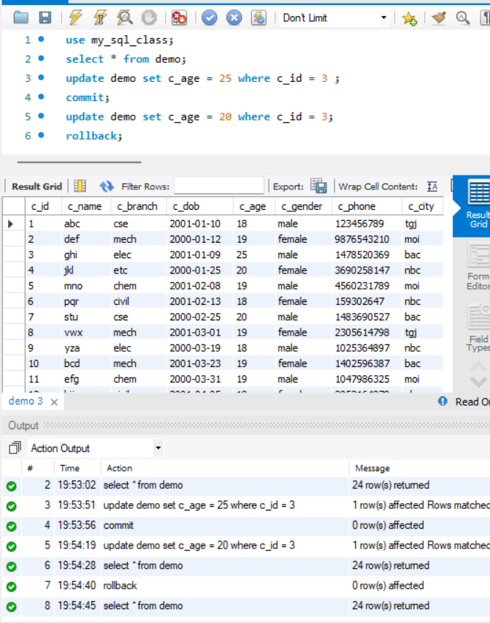

**COMMIT:**

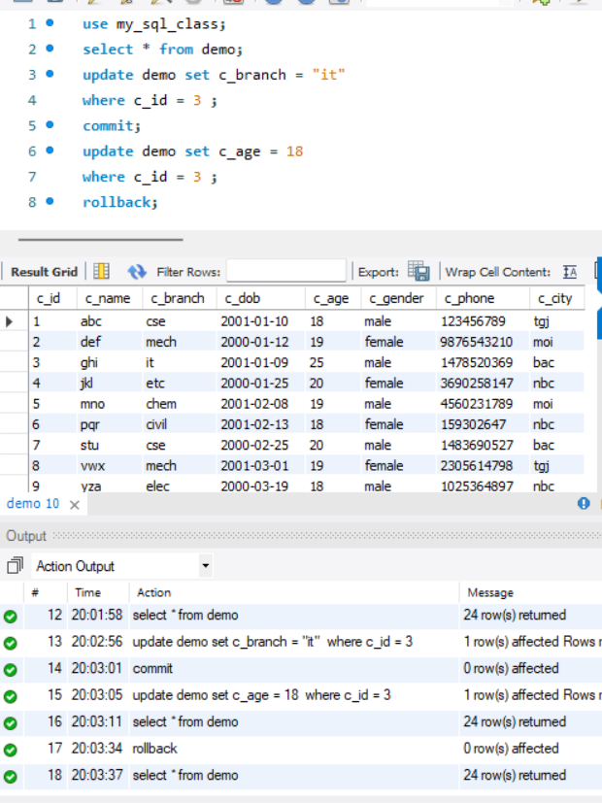

**DELETE COMMAND IN MYSQL:**

**Delete from table_name where condition;**

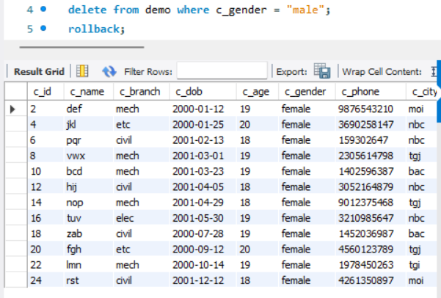

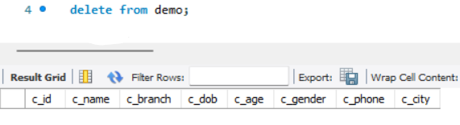

**PRIMARY KEY AND FOREIGN KEY IN MYSQL: ADD FROM HERE**

Primary key always has unique data. A primary key can not have null value. a table can contain only one primary key constraints.

Create table table_name( id int not null auto_increment, name varchar(50) not null, age int not null, city varchar(50) not null, PRIMARY KEY(id) FOREIGN KEY(city) references table_name1(id));

“alter table table_name add PRIMARY KEY(id);”

A foreign key is used to link two tables together. A foreign key in one table used to point primary key in another table.

Create table table_name1(id int not null auto_increment, city varchar(50) not null, PRIMARY KEY(id));

Alter table table_name add FOREIGN KEY(city) references table_name1(id);

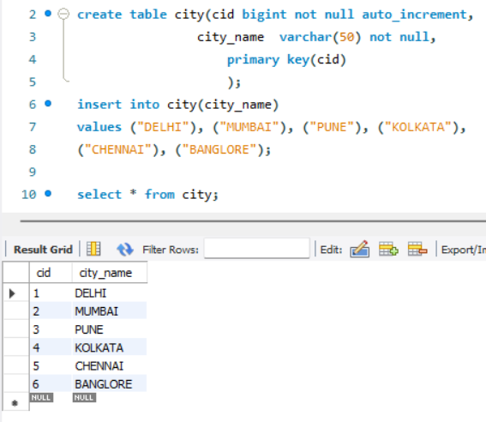

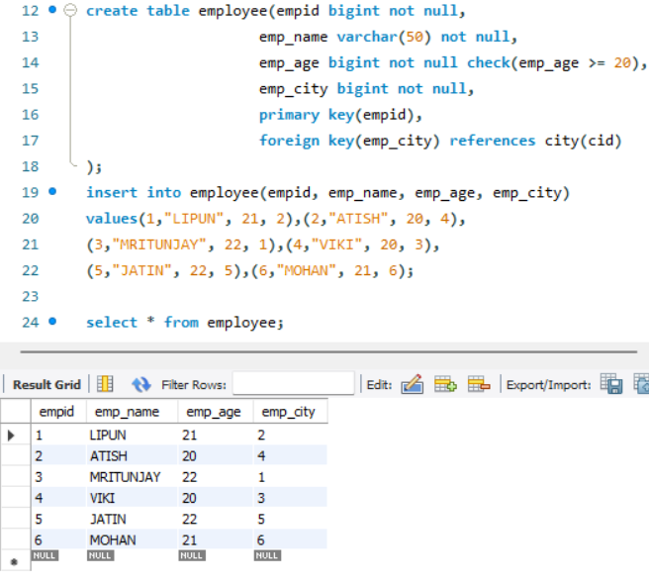

**MYSQL JOINS:**

**1. INNER JOIN:**

the inner join selects records that have matching values in both tables.

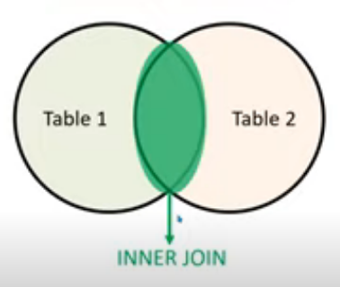

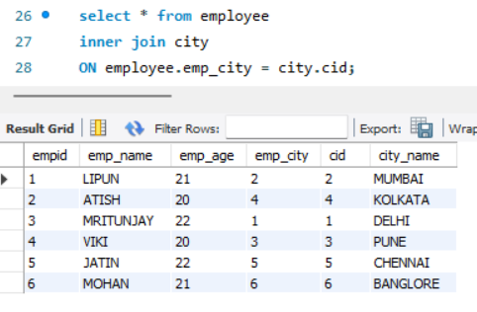

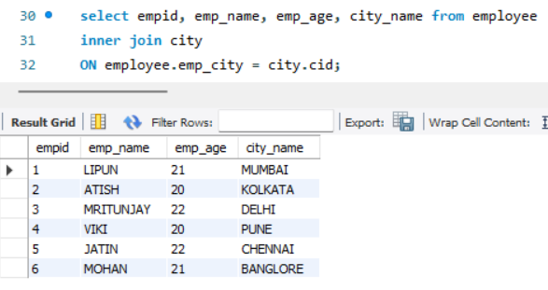

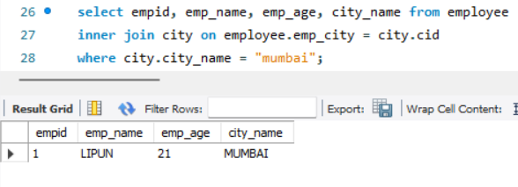

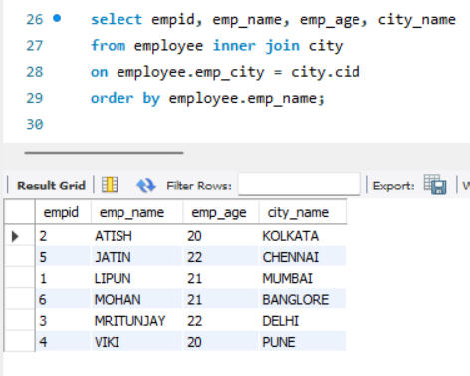

**2. LEFT JOIN:**

The left join returns all records from the left table(table1) and the matched records from the right table(table2).

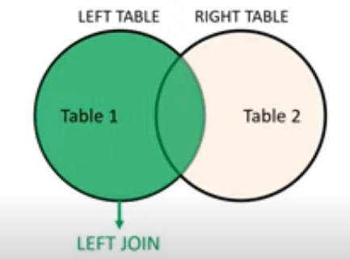

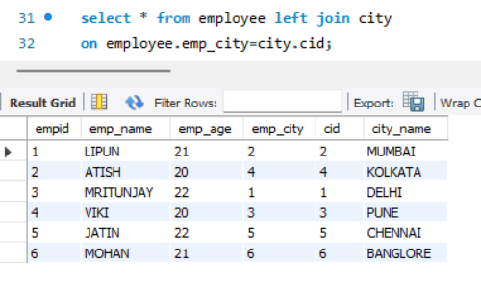

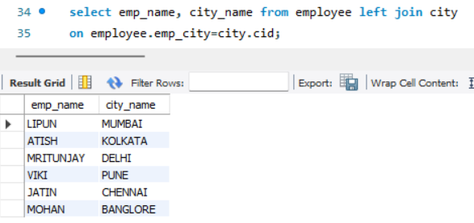

**3. RIGHT JOIN:**

The right join returns all records from the right table(table2) and the matched records from the left table(table1).

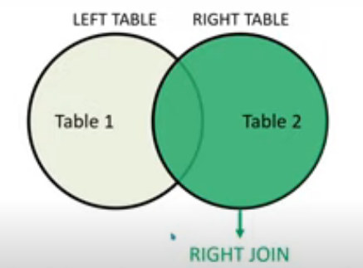

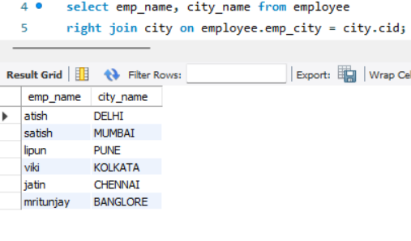

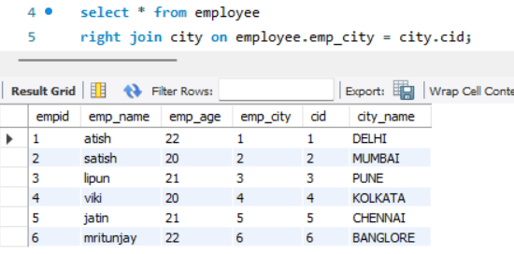

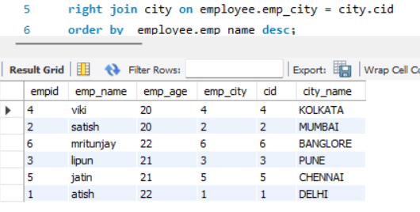

**4. CROSS JOIN:** select * from table1 cross join table2; = select * from table1,table2;

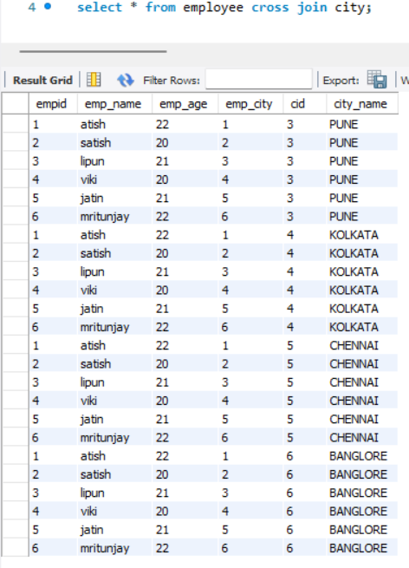

**JOIN MULTIPLE TABLES:**

**select columns from table1 inner join table2 on table1.column_name = table2.column_name**

**inner join table3 on table1.column_name = table3.column_name;**

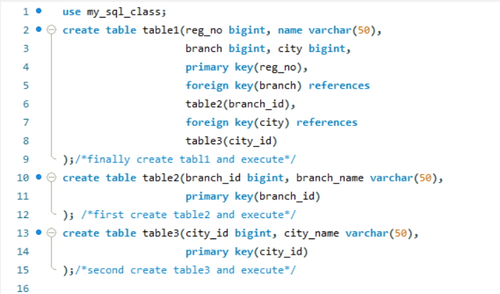

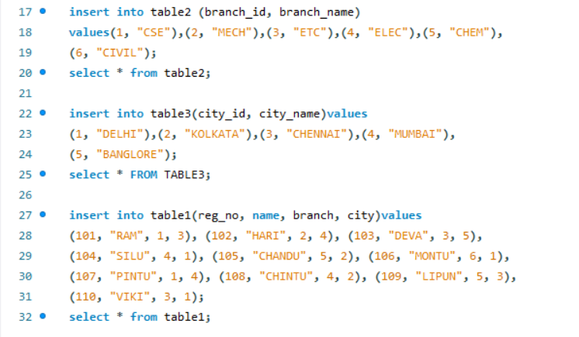

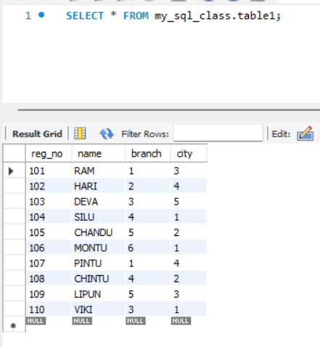

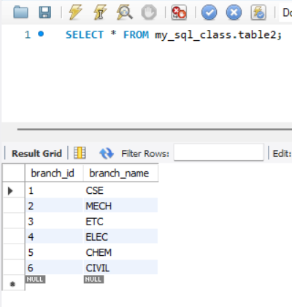 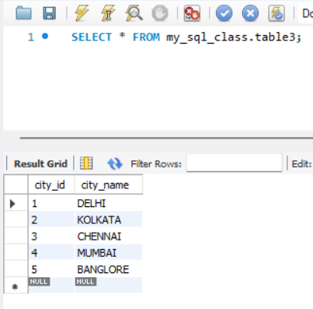

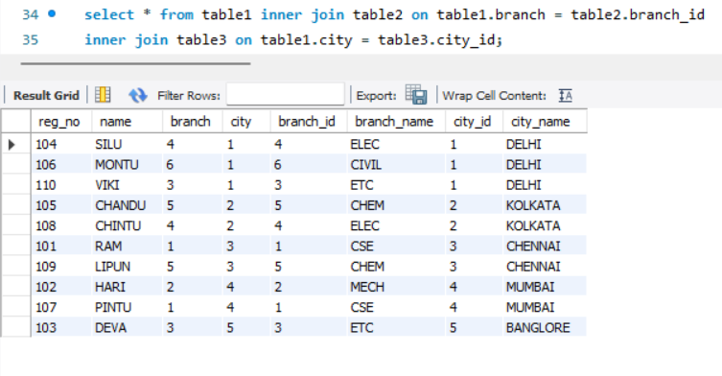

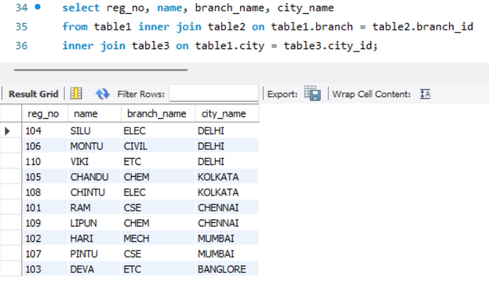

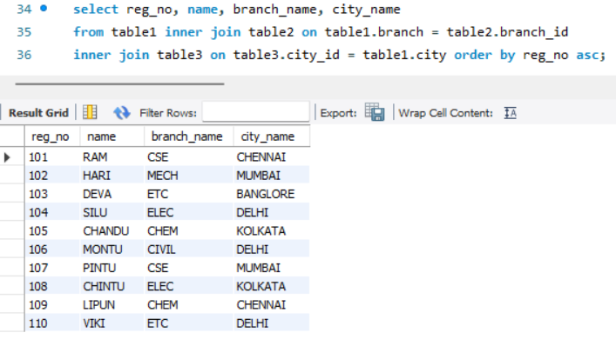

**MYSQL GROUP BY AND HAVING CLAUSE:**

The group by clause is used in conjunction with the select statement and aggregate functions to group rows together by common column values.

**Syntax of group by:**

**select columns from table_name where condition group by column_name(s) order by clause;**

**select columns from table1 inner join table2 on table1.column_name = table2.column_name where condition group by column_name(s);**

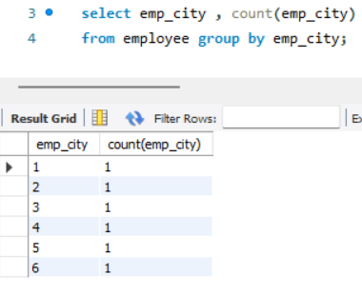

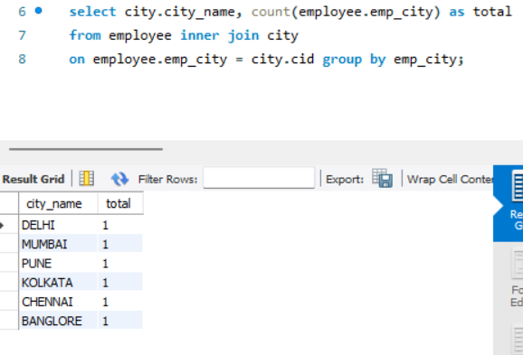

**Syntax of having:**

**select columns from table_name group by column_name, having condition;**

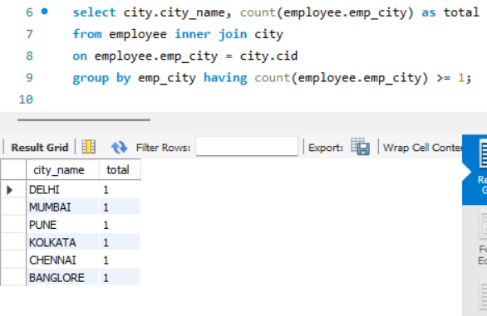

**MYSQL SUBQUERY with EXISTS & NO EXISTS:**

**Select columns from table1 where column = (select columns from table2 where condition);**

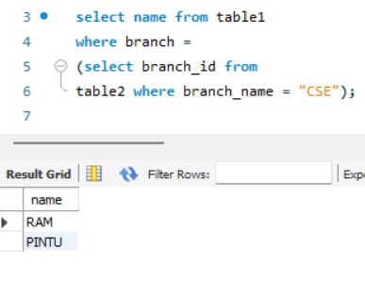

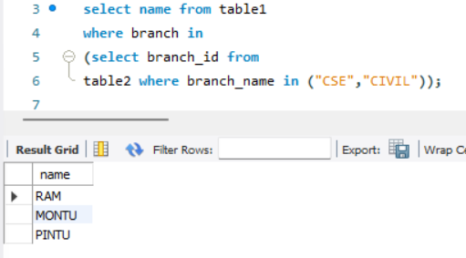

**select columns from table1 where exists(select column from table2 where condition);**

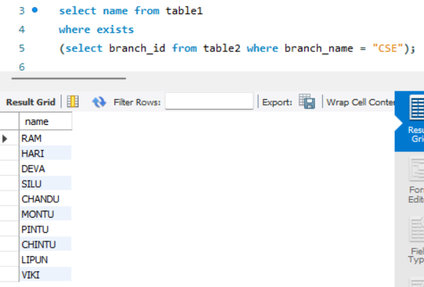

**select columns from table1 where not exists(select column from table2 where condition);**

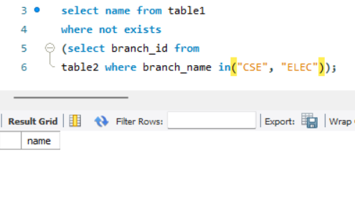

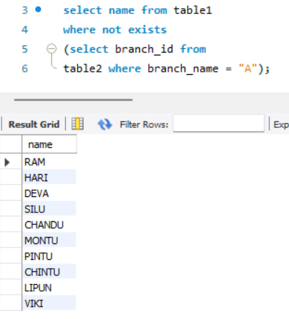

**MYSQL UNION AND UNION ALL:**

select column1, column2,… from table1 union/union all select column1, column2 from table2;

**student table lecture table**

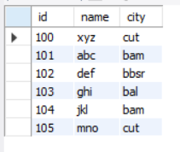 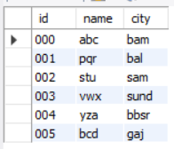

**MYSQL UNION:**

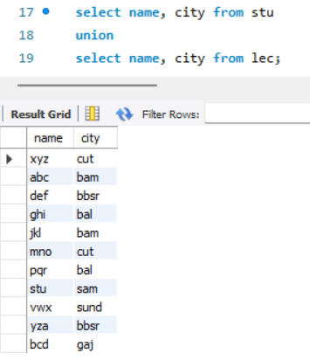

**RULES OF UNION AND UNION ALL:**

1. each select statement within union must have the same number of columns.

2. the columns must also have similar data types.

3. the columns in each select statement must also be in the same order.

**MYSQL UNION ALL:**

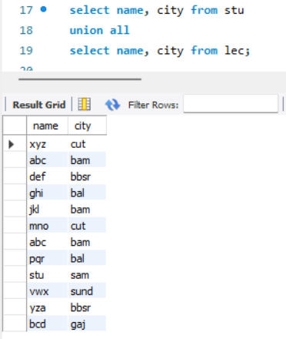

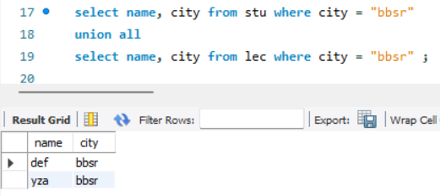

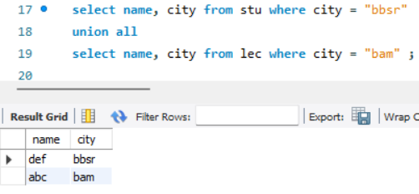

select * from students where city = (select cid from city where city_name = “city name”)

Union all

select * from lecture where city = (select cid from city where city_name = “city name”);

select * from students inner join city on student.city = city.cid where city.name = “city name”

union all

select * from lectures inner join city on lectures.city = city.cid where city.name = “city name”;

**MYSQL IF & CASE CLAUSE:**

**IF CLAUSE:**

select column1, column2,…. If(condition, true result, false result) as alias_name from table_name;

select id, name, percentage, if(percentage >= 33, “pass”, “fail”) as result from student;

**CASE CLAUSE:**

Select column1, column2,…. case

when condition1 then result1 when condition1 then result1 when condition1 then result1

else results end as alias_name from table name;

select id, name, percentage

case

when percentage >= 80 and percentage <= 100 then “A”

when percentage >= 70 and percentage < 79 then “B”

when percentage >= 50 and percentage < 69 then “C”

when percentage >= 30 and percentage < 49 then “FAIL”

else “invalid one”

end as RESULT from students;

update students set

percentage = (case id

when 3 then 65

when 7 then 82

end) where id in (3,7);

**MYSQL ARITHMETIC FUNCTION:**

Pi() rand() asin() Round() abs()

acos() Ceil() sign() atan() cos()

Floor() sin() atan2() Pow() radians()

cot() Sqrt() tan()

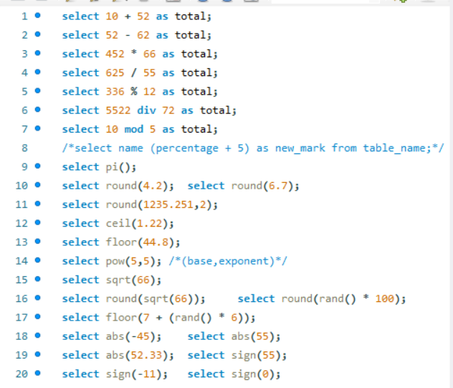

**ADDITION:**

Addition two number. Ex: select 15 + 36 as addition

**SUBTRACTION:**

Subtraction of two number. Ex: select 63 – 22 as subtraction.

**MULTIPICATION:**

Multiplication of two number. Ex: select 36 * 11 as multiplication.

**DIVISION:**

Division of two number. Ex: select 48 / 12 as division. OR select 88 div 20 as division.

**MODULO:**

Modulo of two number. Ex: select 56 % 8 as modulo. OR select 144 mod 11 as modulo.

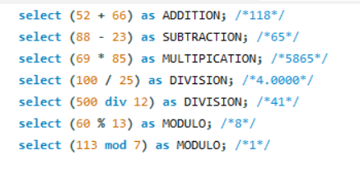

**NOT OPERATOR:**

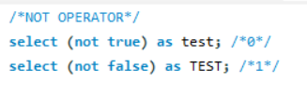

**AND OPERATOR:**

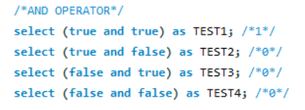

**NAND OPERATOR:**

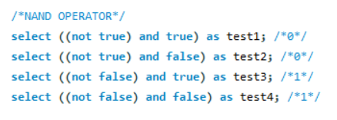

**OR OPERATOR:**

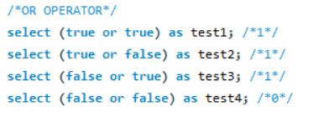

**NOR OPERATOR:**

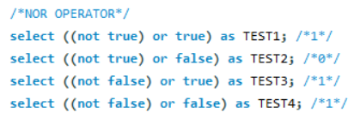

**EX-OR OPERATOR:**

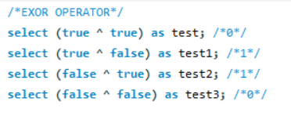

**EX-NOR OPERATOR:**

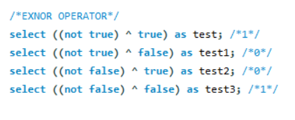

**RELATIONAL OPERATOR:**

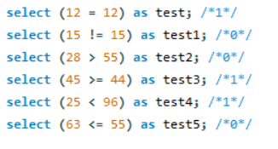

**BITWISE AND OR AND EXOR OPERATOR:**

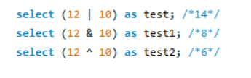

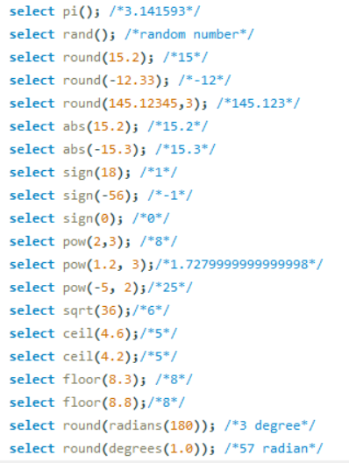

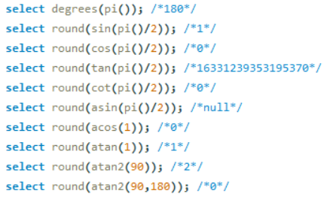

**MY SQL STRING FUNCTION:**

**select id, upper(column_name) as alias from tablename;**

**Upper()/ucase() lower()/lcase() length() char_length()**

**concat() concat_ws()**  **ltrim() rtrim()**

**trim()**   **position() locate()** **instr()**

**substring()/substr() mid() right() left()**

**substring_index()** **lpad()**   **rpad() space()**

**reverse() repeat()** **replace() strcmp()**

**field() find_in_set() format()** **hex(str)**

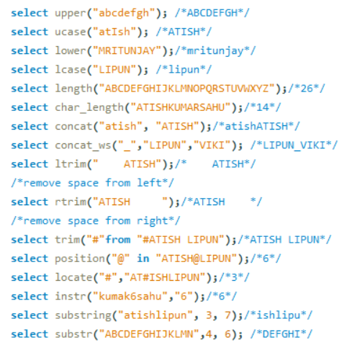

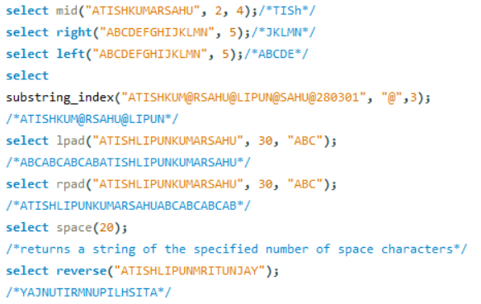

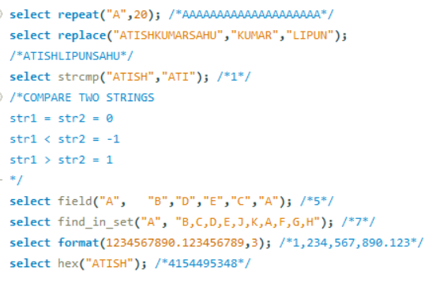

**MY SQL DATE FUNCTION:**

**curdate**  **dayofmonth**  **yearweek** **datediff** **form_days**

**current_date** **dayofweek** **extract** **period_add** **period_diff**

**sysdate** **dayofyear** **date_add** **date_format str_to_date**

**now**  **week**   **adddate** **makedate** **date_sub**

**last_day** **weekday** **subdate** **year dayname**

**day** **weekofyear**

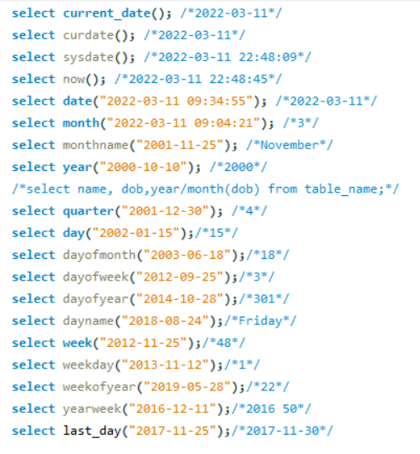

**LIST OF PARAMETER WITH EXTRACT FUNCTION IN MYSQL:**

**microsecond minute_microsecond minute_second hour_microsecond**

**second** **hour_second**  **day_microsecond**  **day_second**

**minute** **day_minute**  **day_hour** **year_month**

**hour**  **day week month**

**quarter year**

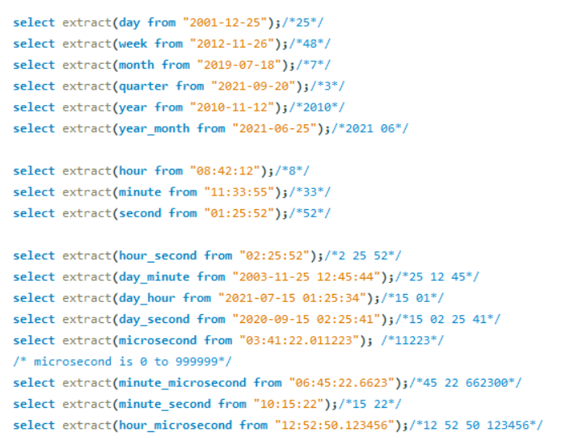

**LIST OF ADDUNITS IN MYSQL:**

**adddate & date_add both functionalities are same and list are also same both are add whatever you give.**

**you can use these list to the subdate also subdate actually subtract whatever you give.**

**microsecond second minute hour**  **day week month**

**quarter year** **second_microsecond minute_microsecond**

**minute_second** **hour_microsecond**  **hour_minute** **day_microsecond**

**day_second day_minute**  **day_hour year_month**

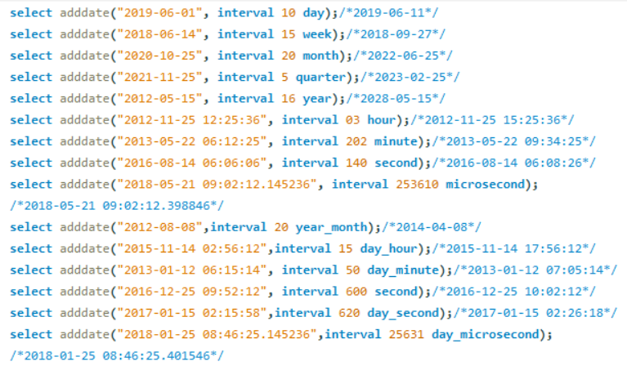

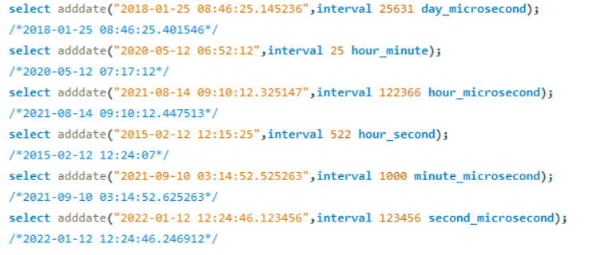

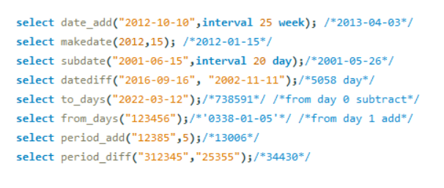

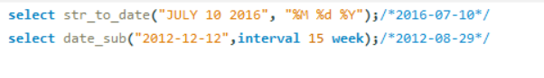

**LIST OF DATE FORMATS IN MYSQL**

**DAY:**

**%d => (01 to 31)**

**%e => (0 to 31)**

**%D => (st, nd, rd, th,…)**

%j => (001 to 366)

**MONTH:**

**%M => (January to December)**

**%b => (jan to dec)**

**%m => (00 to 12)**

%c => (0 to 12)

**YEAR:**

**%Y => 2019**

**%y => 19**

**WEEK:**

%a => mon

%W => MONDAY

%w => 01 TO 06

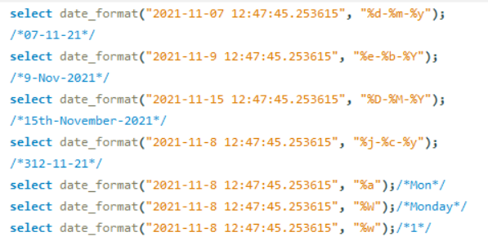

**LIST OF TIME FORMAT IN MYSQL:**

**HOUR:**

%h => (01-12)

%H => (00 - 23)

%g => (1 - 12)

%G => (0 - 23)

**MINUTES:**

%i = (00 -59)

**SECONDS:** **MICROSECONDS**

%s = (00-59) %f = 000000 - 999999

**MERIDIEM:**

%p = am or pm

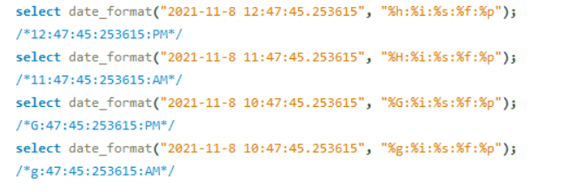

**TIME FUNCTION IN MYSQL:**

**curtime() current_timestamp localtime**

**localtimestamp timestamp time**

**timediff hour minute**

**second microsecond addtime**

**subtime maketime time_format**

**sec_to_time time_to_sec**

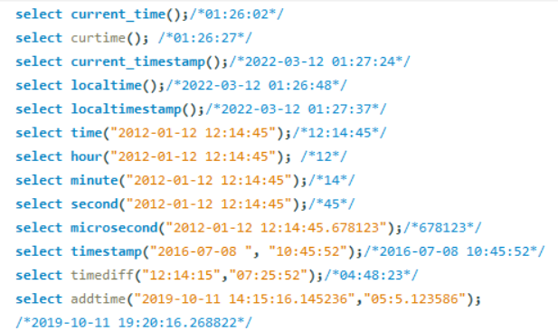

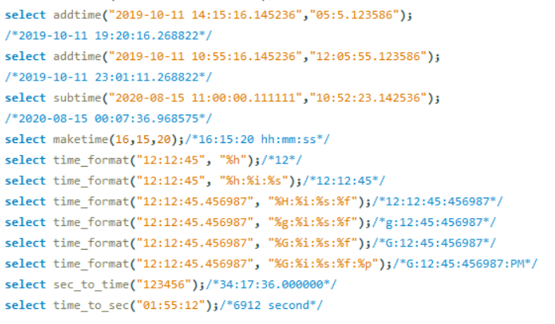

**ALTER COMMAND IN MYSQL:**

**1. add column in a table:**

**alter table table_name add column_name datatype;**

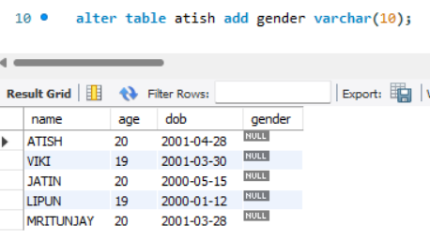

**2. changing data type of a column:**

**alter table table_name modify column_name datatype;**

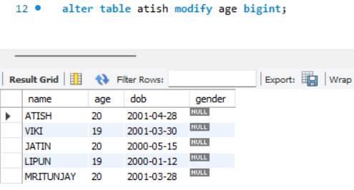 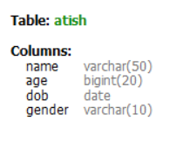

**3. change column name:**

**alter table table_name change column_name new_column_name datatype**;

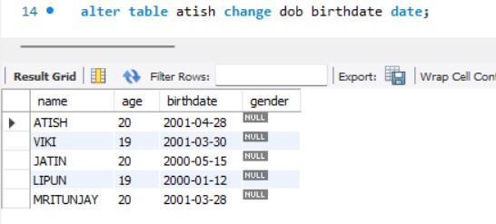

/*alter table table_name auto_increment = 4;*/ => use this command for testing

**5. changing column position:**

alter table table_name modify column_name datatype after column_name;

column_name = after this column you trying to store your column.

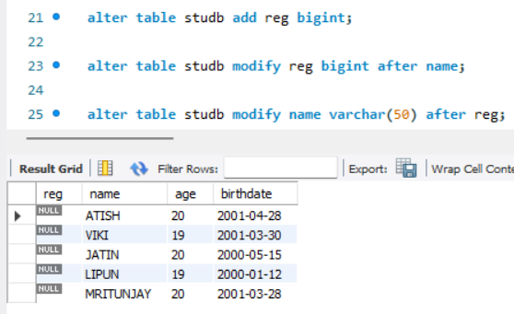

**6. delete column:**

**alter table table_name drop column column_name;**

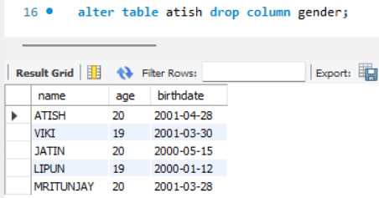

**7. renaming tables:**

**alter table table_name rename new_table_name;**

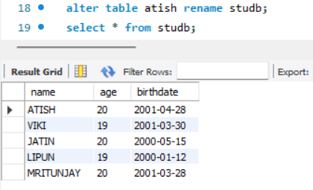 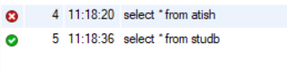

**DROP & TRUNCATE COMMAND IN MYSQL:**

Drop = it delete the whole table. Drop table table_name;

Truncate = it delete the all data of the table. Truncate table table_name;

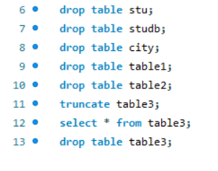

**VIEW COMMAND IN MYSQL:**

**create view view_name as select columns from table1 inner join table2**

**on table1.column_name = table2.column_name;**

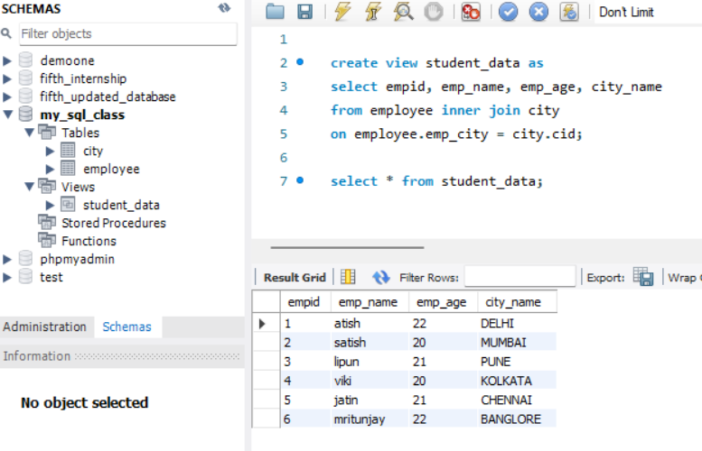

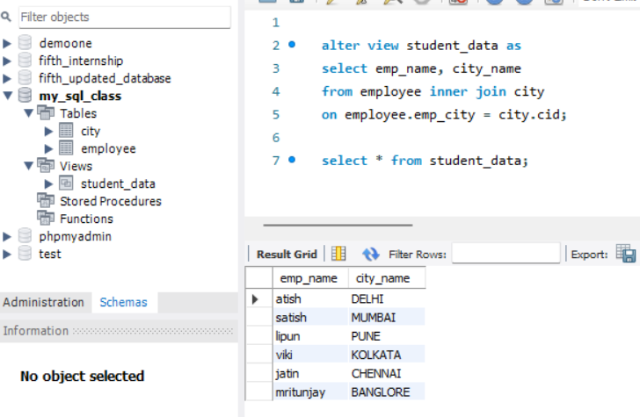

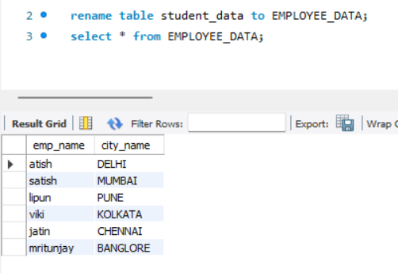

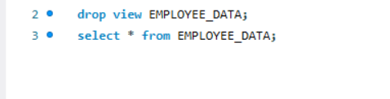 => to drop the view table.

**ADVANTAGES OF VIEW COMMAND:**

Simplify the complex query.

Provides extra layer of security.

**DISADVANTAGES OF VIEW COMMAND:**

Performance decreases.

Dependency on table.

**MYSQL INDEX COMMAND:**

create index index_name on table_name(column1, column2,column3,……);

drop index index_name on table_name;

**SOME GUIDELINE OF INDEX COMMAND:**

# automatically create the indexes for primary key and unique columns.

# Index columns that you frequently use to retrieve the data.

# Index columns that are used for joins to improve join performance.

# Avoid columns that contain too many null values.

# Small tables do not required indexes.

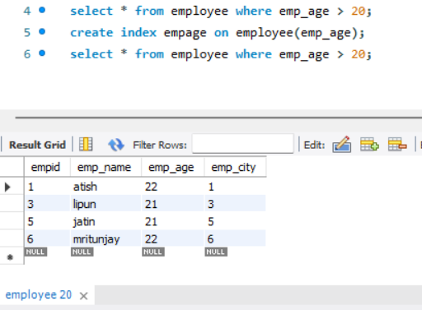

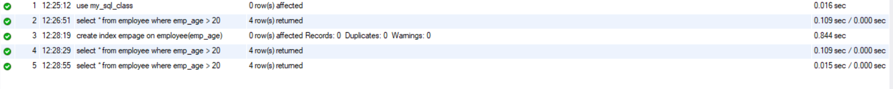

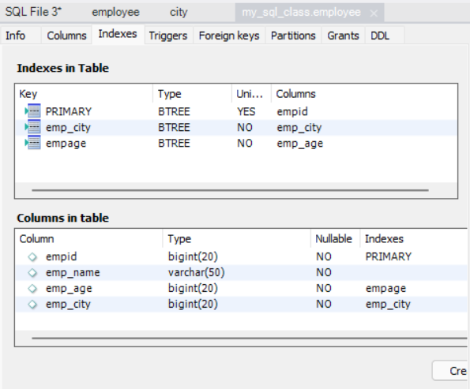

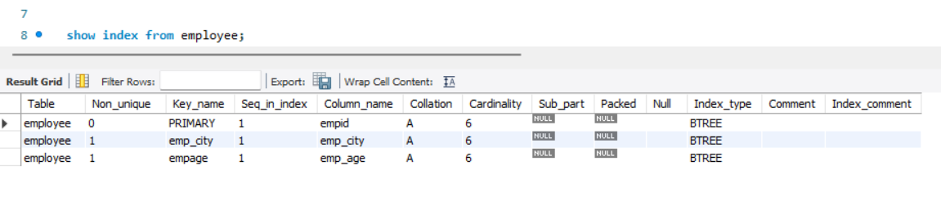

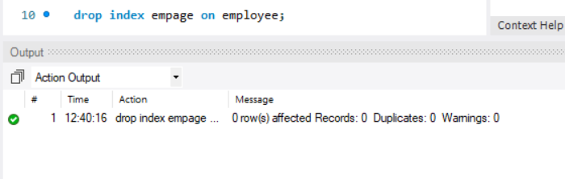

**ADD AN IMAGE AND ANY TEXT FILE BY MYSQL COMMAND:**

